Day-2 DHCP configuration Theory
Q1. In Cisco Packet Tracer, set up a simple network with one DHCP server and two client PCs. Configure the DHCP server to assign IP addresses automatically, then verify on each PC that it receives a different IP address from the DHCP pool.
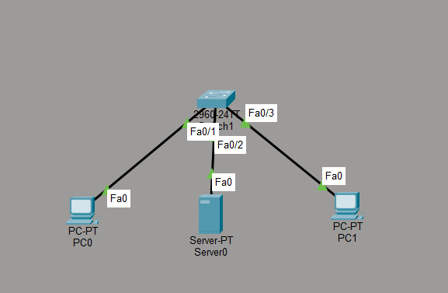
Ans:

Figure 1: DHCP Network Topology in Cisco Packet Tracer

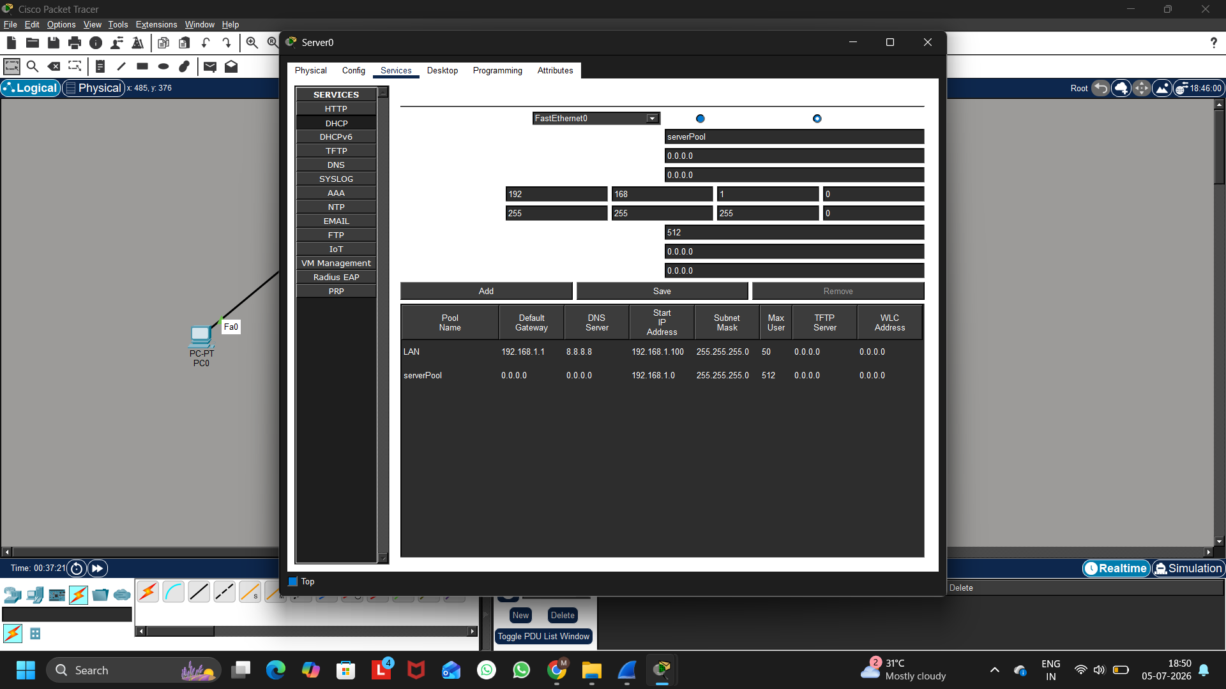
Figure 2: DHCP Server Configuration and Address Pool in Cisco Packet Tracer
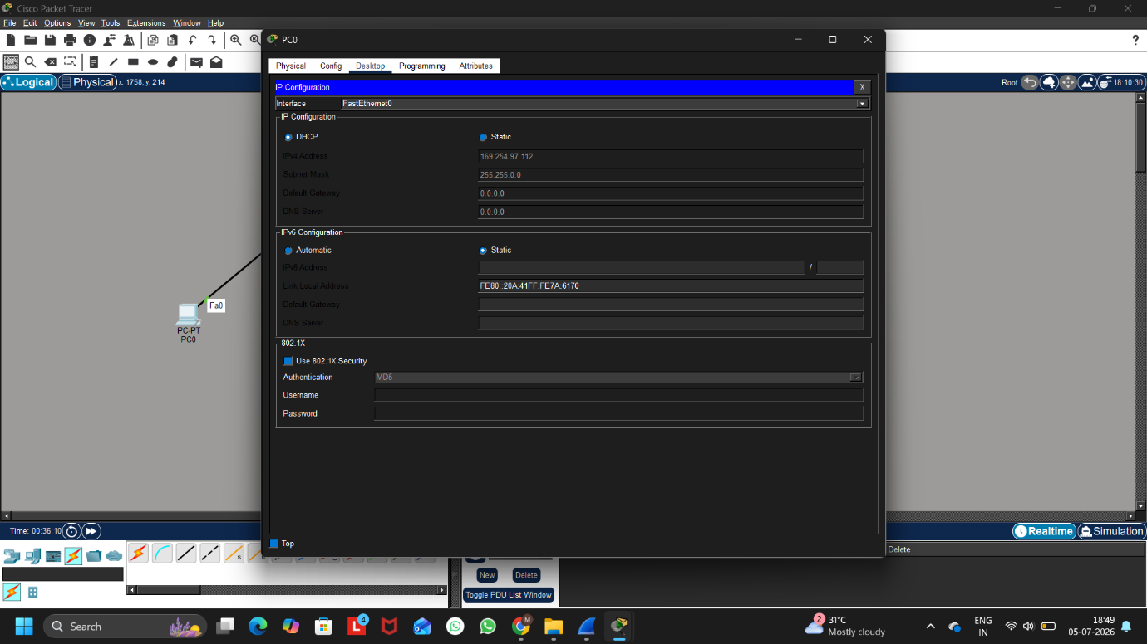
Figure 3: PC0 Receiving an IP Address Automatically from the DHCP Server
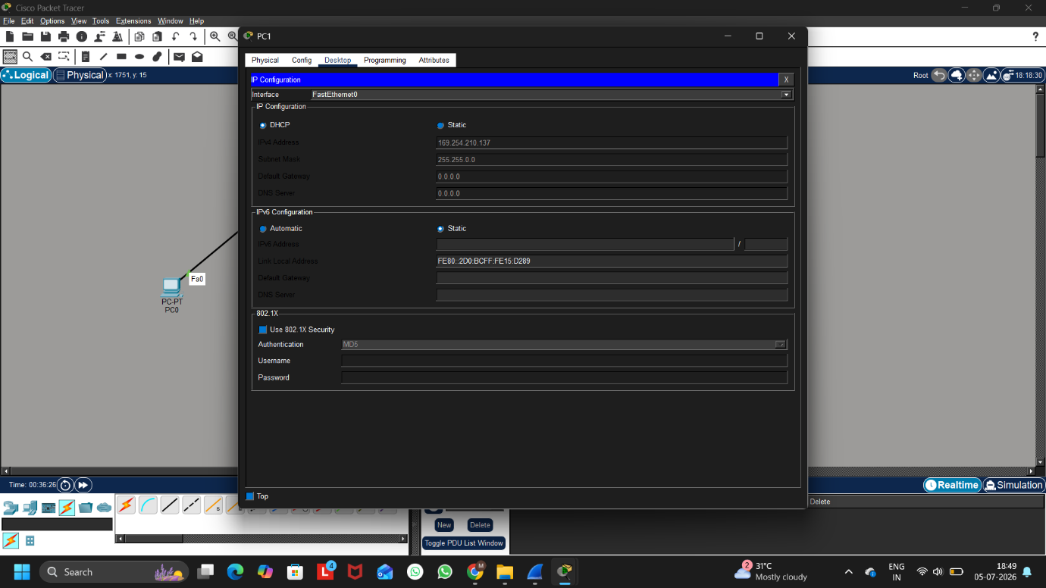
Figure 4: PC0 Receiving an IP Address Automatically from the DHCP Server
Configuration Summary:
A DHCP server was configured in Cisco Packet Tracer to automatically assign IP addresses to client devices. Both PC0 and PC1 were configured to obtain IP addresses automatically using DHCP. After verification, PC0 and PC1 successfully received different IP addresses from the configured DHCP pool, confirming that the DHCP server was working correctly.
Verification
- PC0 IP Address: 169.254.97.112
- PC1 IP Address: 169.254.210.137
Result
The DHCP server successfully assigned unique IP addresses to both client PCs from the configured DHCP pool.

Q2. Draw a sequence diagram (hand-drawn or digital) that clearly shows each step of the DHCP process: Discover, Offer, Request, and Acknowledge, labeling the sender and receiver at each stage.<br><br><em><strong>Hint:</strong> Use arrows to show the direction of each message between client and server.</em>
Ans:
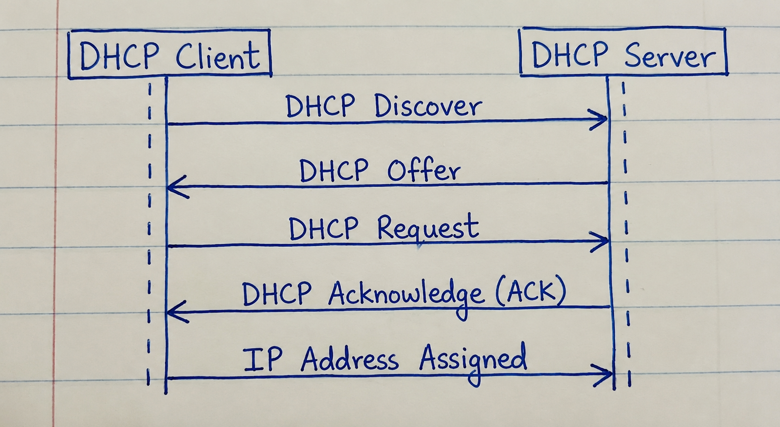
Figure 1: DHCP Sequence Diagram Showing Discover, Offer, Request, and Acknowledge (DORA) Process
DHCP Process:
- DHCP Discover – The client broadcasts a request to find available DHCP servers.
- DHCP Offer – The DHCP server offers an available IP address to the client.
- DHCP Request – The client requests the offered IP address from the server.
- DHCP Acknowledge (ACK) – The server confirms the request and assigns the IP address to the client.
Q3.Change the DHCP pool range on your Cisco Packet Tracer DHCP server so that only one IP address is available. Add two PCs and observe what happens when both try to get an IP address. Take a screenshot of the result and explain in 2-3 lines why only one PC succeeds.
Ans:
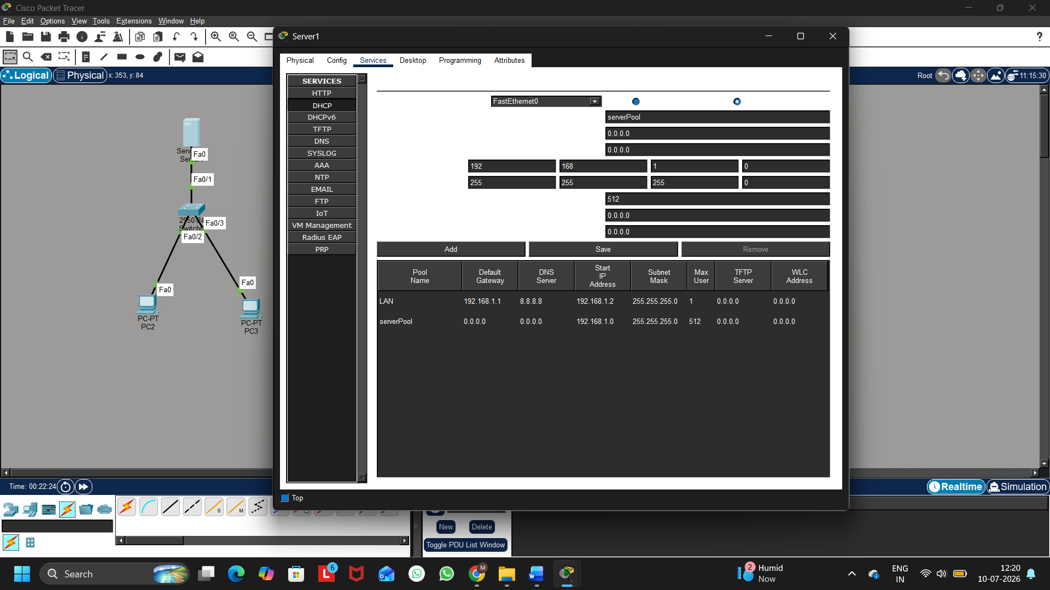
Figure 1: DHCP Server Pool Configuration
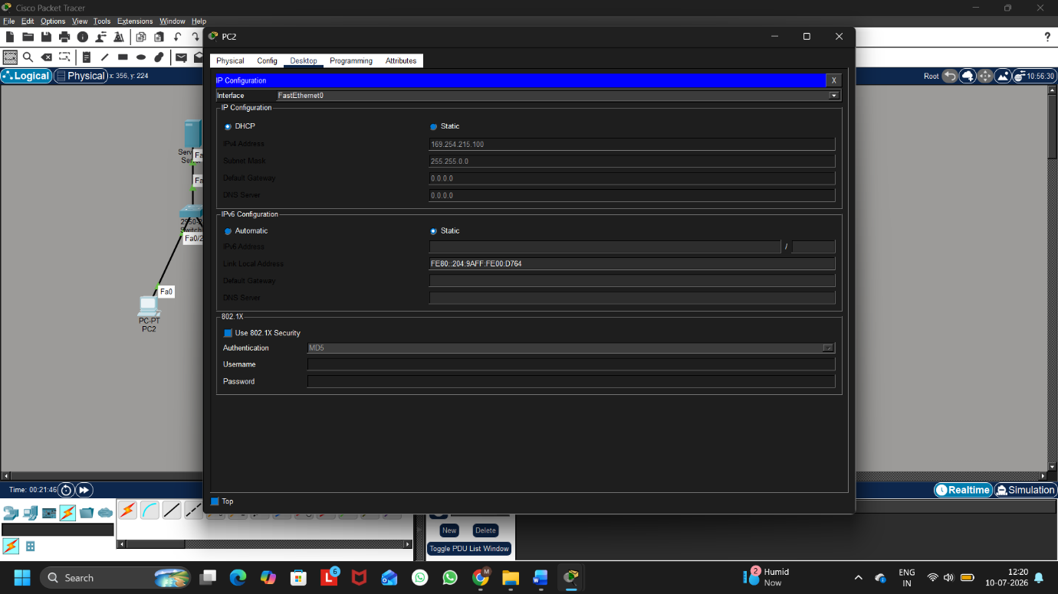
Figure 2: PC2 Successfully Obtaining an IP Address from the DHCP Server
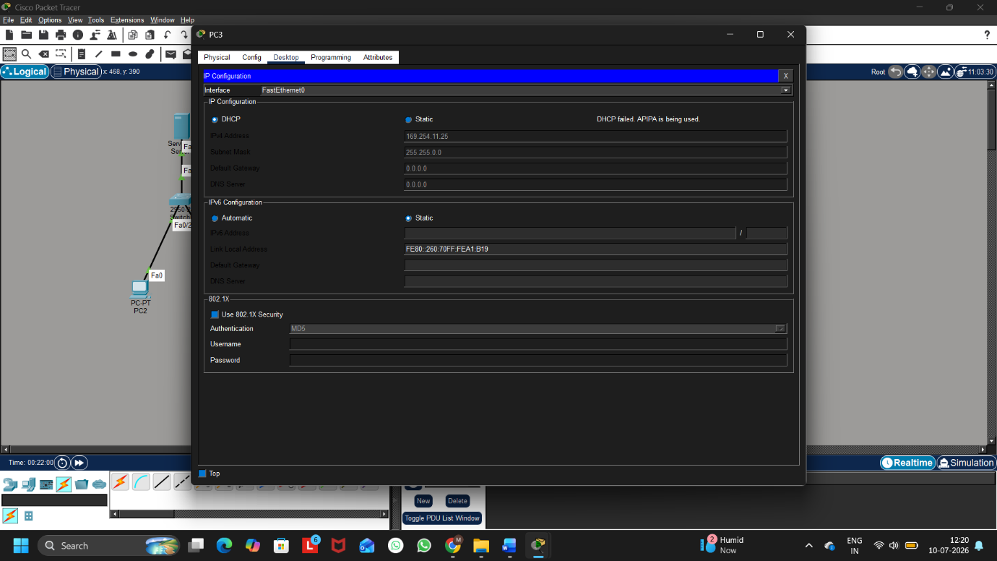
Figure 3: PC3 Failing to Obtain an IP Address Due to Limited DHCP Pool

Reason Why Only One PC Succeeds:
The DHCP server has only one IP address available in its pool. The first PC gets that IP address successfully. The second PC cannot get an IP address because no IP addresses are left in the DHCP pool.

Q4. Simulate a Zomato-style restaurant WiFi scenario in Cisco Packet Tracer: configure a DHCP server to provide IP addresses to both a laptop and a smartphone (use a generic PC as smartphone). Show the assigned IPs and explain why DHCP is useful in this situation.
Ans:
Assigned IP Addresses:
Device | Assigned IP Address
Laptop (PC0) | 192.168.10.2
Smartphone (PC1) | 192.168.10.3

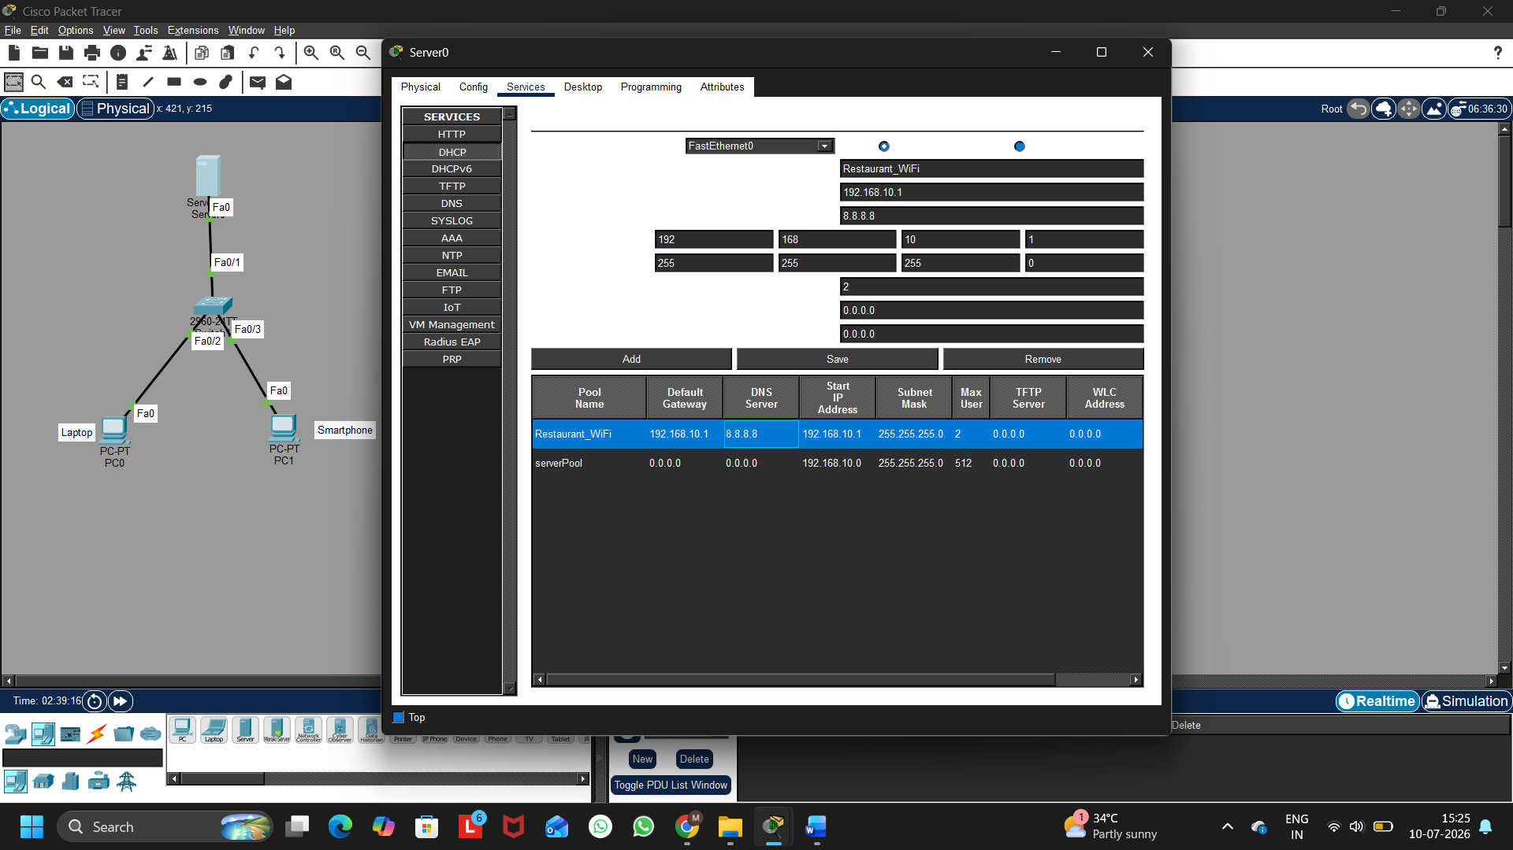
Figure 1: DHCP Server Configuration for Restaurant WiFi

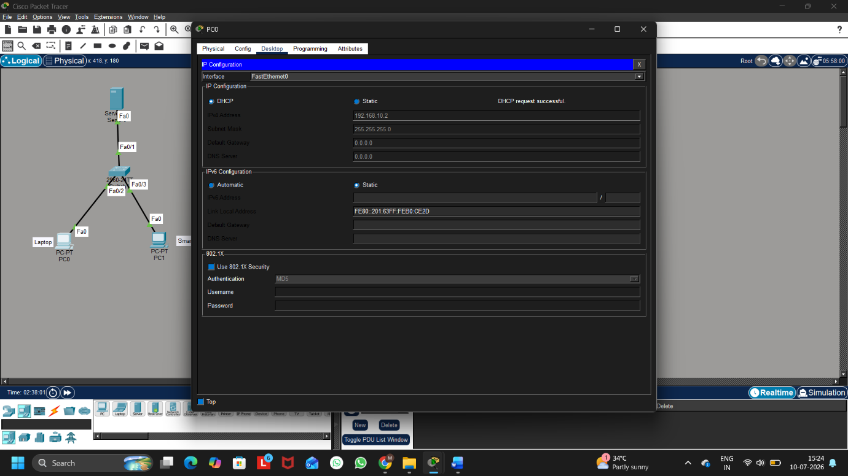
Figure 2: Laptop Receiving an IP Address via DHCP

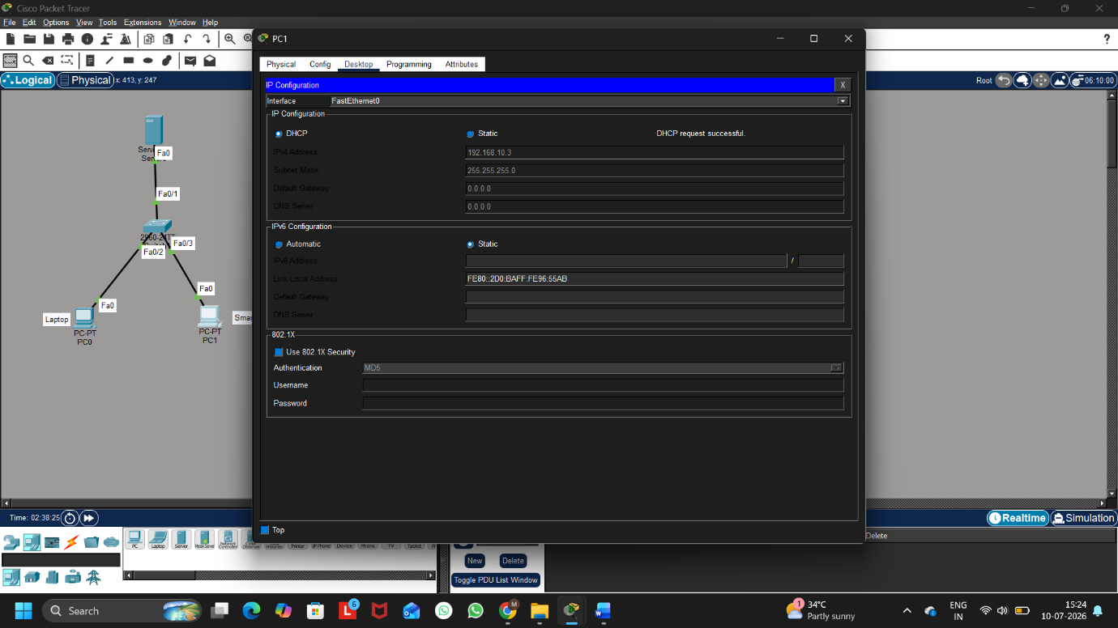
Figure 3: Smartphone Receiving an IP Address via DHCP
Why DHCP is Useful in This Situation:
DHCP is useful because it automatically assigns IP addresses to all devices connected to the restaurant's Wi-Fi network. This eliminates the need for manual IP configuration, prevents IP address conflicts, and allows customers to connect quickly and easily.

